About me:

Date and place of birth: 02.01.1990. Niš
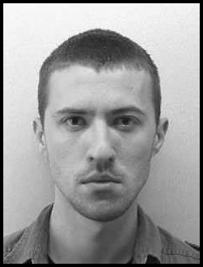
Student of Economics, singer in the choir, practicing fencing, learn foreign languages, interested in the new technologys .

Ready to learn, makes new contacts and improve in all areas.

Favorite Quotations:

Fear is just a feeling.
Victory loves preparation.
Persistence is desirable.

Education:

- 2006-2009 High school in Kusumlija
- Scholarships of the Republic of Serbia
- 2009-2014(expectation) Faculty of Economics Belgrade- Depertment of Trade Management and Marketing
- Scholarships of the Republic of Serbia
- Scholarships of town Kursumlija
- 2014/2016 School of Music(singing)
- Wrote many papers on the topic of marketing and trade like:
- Retail channels of Louis Vuitton
- Supply chain of Zara and HM
- Strategies of retail company Delhaize
- Tourism in Serbia
- Case study:
- Won a summer internship at the company Mercator for designing an Easter campaign
- Second place Aisece case challenge / IDEA Online shopping
- “Budi kulturan” case stady for Guitar Art Festival
- During the study visited several seminars on entrepreneurship, small business development, management by projects, green energy
- iSerbia-iAcademy: modul Event management
- Danube innovation Partnership Summer School on Knowledge and Tehnology Transfer –Belgrade, September 2014
- II prize for PRA essay competition - City and visual communication

Plans for future: Postgraduate Studies in ICT school - Electronic Business in Belgrade

Experience:
- two-week practice in 'Energoprojekt': commercial, accounting, marketing
- ex member of NGO Serbian Green Youth
- work survey for GFK
- involved in the promotion of tourism spa break in Kursumlija
- recently participated in a student forum Seliger in Russia.
- worked in the logistic company Milsped
- participated in the organization of workshops in high schools about First and Second World War as a singer and organizer
- Freelance SEO writing for many websites
Languange skills:

English(B1) Spanish(A2) Russian(B1)
knowledge level: knowledge level: knowledge level:
Writing: good writing: good writing: excellent
Reading: good reading: good reading: excellent
speacking:good speacking:good speacking : good

Teahnical skills:

Microsoft Word, Microsoft Excel(certificate SMARTedu), Microsoft Power Point, Internet i Prezi.

Areas of interest:

Online marketing, mobile technology, social networking, marketing and management in culture and the arts.

