About me:

Date and place of birth: 02.01.1990. Niš
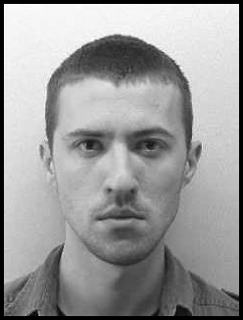
Student of Economics, singer in the choir, practicing fencing, learn foreign languages, interested in the new technologys .

Ready to learn, makes new contacts and improve in all areas.

Favorite Quotations:

Fear is just a feeling.
Victory loves preparation.
Persistence is desirable.

Education:

- 2006-2009 High school in Kusumlija
- Scholarships of the Republic of Serbia
- 2009-2014(expectation) Faculty of Economics Belgrade- Depertment of Trade Management and Marketing
- Scholarships of the Republic of Serbia
- Scholarships of town Kursumlija
- 2014/2016 School of Music(singing)
- Wrote many papers on the topic of marketing and trade like:
- Retail channels of Louis Vuitton
- Supply chain of Zara and HM
- Strategies of retail company Delhaize
- Tourism in Serbia
- Won a summer internship at the company Mercator for designing an Easter campaign
- Second place Aisece case challenge / IDEA Onlineshopping
- Won the award for designing the New Year's slogan for Pansport and the company Idea for improvement online store, participated in the Case stadys of other companies where he and his colleagues has been awarded to the top competitors
- During the study visited several seminars on entrepreneurship, small business development, management by projects, green energy
- iSerbia-iAcademy: modul Event management
- Danube innovation Partnership Summer School on Knowledge and Tehnology Transfer –Belgrade, September 2014
- II prize for PRA essay competition - City and visual communication

Plans for future: Postgraduate Studies in ICT school - Electronic Business in Belgrade

Experience:
- two-week practice in 'Energoprojekt': commercial, accounting, marketing
- ex member of NGO Serbian Green Youth
- work survey for GFK
- involved in the promotion of tourism spa break in Kursumlija
- recently participated in a student forum Seliger in Russia.
- worked in the logistic company Milsped
- participated in the organization of workshops in high schools about First and Second World War as a singer and organizer
Languange skills:

English(B1) Spanish(A2) Russian(B1)
knowledge level: knowledge level: knowledge level:
Writing: good writing: good writing: excellent
Reading: good reading: good reading: excellent
speacking:good speacking:good speacking : good

Teahnical skills:

Microsoft Word, Microsoft Excel(certificate SMARTedu), Microsoft Power Point, Internet i Prezi.

Areas of interest:

Online marketing, mobile technology, social networking, marketing and management in culture and the arts.

