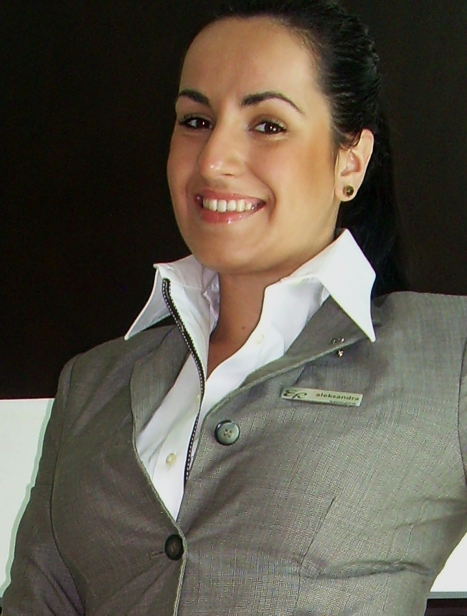
Mihajlovic Aleksandra
Dunavska 15, 22320 Indjija, Serbia
amihajlovic15488@gmail.com

OBJECTIVE
Organized, innovative and highly motivated graduated hotel manager,
devoted team player with great customer service skills.

EDUCATION
- Faculty of natural sciences, Management in hospitality, University Novi Sad, Serbia 2007-2012
Bachelor Degree
- Language High School, Indjija 2003-2007
Diploma

WORK EXPERIENCE

- Front Office Supervisor at Hyatt regency in Belgrade 2014
To control the work of FO and Guest Services officers and to ensure that all provided services are available to the guests; to assign duties and responsibilities to the others and to assist them if necessary; to keep track of guest accounts, do the reports; communication with housekeeping on daily bases; to maintain good working atmosphere; to organize meeting with all heads of department on daily bases.

- Front Desk and Night Audit Associate at Eden Roc Renaissance in Miami Beach Nov. 2012 – Nov.2013
Personalized and detail Check-in and Check-out activities, processing forms of payment and responding to guest inquires, reports in day and night shift, dispatching requests to housekeeping and engineering, currency exchange, assisting with making schedule and blocking rooms, answering phones, consierge duties. Part of the team who hit 80% guest satisfaction first time in history of hotel, very successful in room upgrades, direct sale and long stay champion. Went trough a successful transition from Mariott to Destination Hotels management.

-Manager Assistant Costa Coffee at Fashion Park Indjija, Serbia 2012
Training of other team members, opening and closing day, the receipt of goods, scheduling of tasks to other team members, ensuring the monitoring of standards of food and coffee drinks, coffee calibration in accordance with standard, filing daily reports, calculations, cash transactions, controlling costs and target budget.

- Sales Associate Polo Ralph Lauren, Atlantic City, USA; 2011
Receipt of goods, unpacking, assembling, placing sensors in the storage and deployment of the appropriate sector in the store, the cashier and work with customers directly on the floor, changing the price, informing customers about discounts and actions

- Hostess, EVO restaurant at Trump Casino, Atlantic City, USA; 2011
Welcoming guests and bringing to the table, making reservations, answering the phone

- Server, Reflections Caffee at Harrah’s Casino, Atlantic City, USA; 2011
Greeting guests, receiving orders, bringing beverages, typing in the micros, taking orders to the guests, cleaning tables, equipment supplies sector, sauces and cutlery

- Front desk agent Sol Kipriotis Village Resort, Kos island, Greece; 2010
Greeting guests, Check-In/Check-Out guests, make hotel reservations and non hotel reservations for restaurants, taxi services, rent a car, payment services, exchange operations, rental of sports equipment, preparation of promotional and information material for guests, laundry services payments

- Banquet Waiter Royal Palace Karadjordjevic, Belgrade, Serbia; 2009 Service at gala dinners, cocktails, receptions of ambassadors, charity dinners and celebrations, setting tables, polishing and cleaning.

- Bar Assistant Rodos Palace Hotel & Convention center, Rodos island, Greece ; 2009
Receiving orders, making drinks and carrying to the table, cleaning tables and washing and polishing glasses, tooking the necessary food and fruit from a central kitchen, opening and closing of the bar
- Waiter Sol Kipriotis Village, Kos island, Greece; 2008
Cleaning tables, polishing silverware and dishes, filling consumable material

SKILLS

Computer/technical skills
Opera, PMS, Micros, GuestWare, Hotel Expert, Vision, Microsoft Office, Singular Logic.
Language ability
English (advanced); Spanish (intermediate); German (intermediate); French (basic).

Certifications
- LCCI Business English 2012
- EIAT Conference (Education and Industry Advancing Together); 2008
- Animator in tourism certificate 2009

INTERESTS
Traveling, vine, learning new languages, books and movies…

