Irina Đorđević
Curriculum Vitae

Date of birth: 7th October 1988.
Address: Belgrade
Phone: 064/2291-317
e-mail: irina_887@hotmail.com

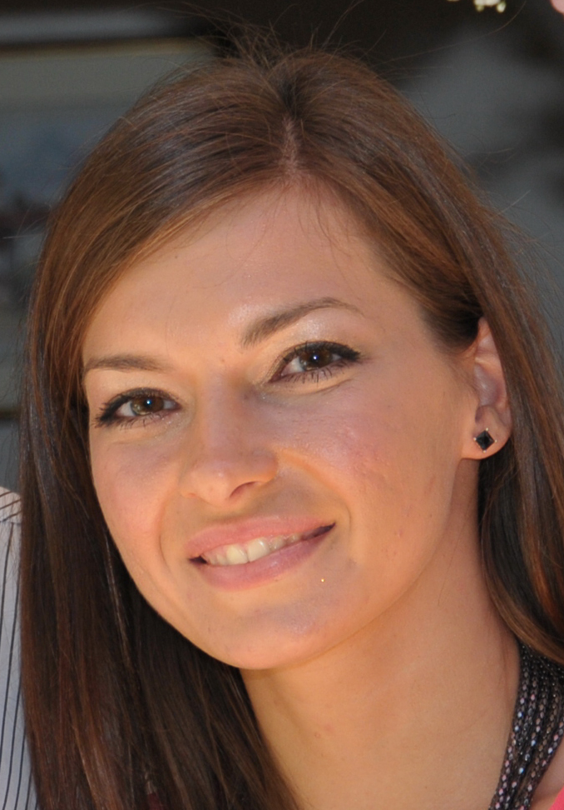

Experience

- 2012. Imperial Tobacco
internship, marketing and sales

* Participation in organization of an event – Gala dinner (improvement
of relationship with the representatives of the retail), poll about the
internal Tobacco magazine, visit to sales points, new product launch
poll data analyses and statistical presentation of gathered data,
introduction to the financial and accounting department

BIG (Belgrade International Games)
volunteer, information department

- 2011. BIG (Belgrade International Games)
volunteer, attache department

* attache for the student football team of Algeria

- 2010-2011. Annual oldtimer meeting - Society of Motoring Historians,
Faculty of Transportation
host for the foreign participants

* accommodation, organisation, taking care of guests, showing tourist
sights of Belgrade, especially to guests from the Italian museum
Bonfanti Vimar (Vicenza)
* team leader of volunteers

- 2010-2011. Akting, company for import-export of air-conditioning equipment

* administrative office work
- 2009. Universiade Belgrade
volunteer, attache department

* attache for the national selection of Namibia

- 2007. Member of Aiesec (international student organization)

* organization of marketing conference

Education

- Student (2012), Faculty of organizational sciences (Project managing), master degree
- Student (2008-2012), Faculty of Geoeconomy (Department for European Union), Megatrend university, Belgrade, average mark 9.6
- High school (2007), XII Belgrade Gimnasium

Languages

- Italian (writing-expert, reading-expert, speaking-expert),
2010. Insitute Leonardo da Vinci in Rome, two-week course
- English (writing-expert, reading-expert, speaking-expert),
- French (writing-expert, reading-expert, speaking-intermediate),
- German (writing-expert, reading-expert, speaking-beginner).

Computer skills

- MS Office, Power Point
- ECDL (European Computer Driving Licence) Certificate

Activities

- B cathegory driving licence, active driver.
- Hip hop dancer at Elyte dance studio, participation at the World hip hop championship 2009. and 2010. Dancer in a theatre musical show „Children from the Zoo station“.

