###### Curriculum Vitae

###### Maja Ignjatović

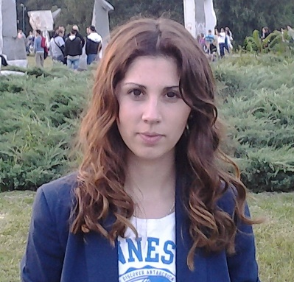

Date of birth: 08.05.1988.   
Address: Žarka Vukovića Pucara 17/2   
               11030 Belgrade  
Mobile phone: 062 / 197-97-03   
                        064 / 167-20-49   
E-mail: majatackica@yahoo.com

# Work experience

**Various part-time jobs**, Belgrade 2007-present

(handing out flyers, translation from English into Serbian, writing term papers,

promotion of different types of drinks, hosting)

**School of Business Skills**, Belgrade February, 2014-present

Position: member of the organizational team

* promotion of lectures organized
* communication with companies
* ensuring financial support

**Belgrad4Youth**, organized by Serbia4Youth, Belgrade 28.02-02.03. 2014.

Position: volunteer

* hosting a group of students from Opatija
* implementation of the group in Belgrade, in accordance with existing programs
* organizing leisure time

**Shipping company ’’Jumbo transfer’’**, Wettringen, Germany November 2012.

Position: trainee

* electronic payments
* filing
* correspondence
* general office jobs

**Shipping company ’’Jumbo transfer’’**, Wettringen, Germany March 2011.

Position: trainee

* filing
* correspondence
* general office jobs

**Agency ’’FA models’’**, Belgrade 2009-2010.

Position: hostess, promoter

* promotion of beverages
* hostess at events organized by the same
* promotion of agency

# Education

Formal education :

**Faculty of Economics**, University of Belgrade 2007- 2014.

Department: foreign trade

Bachelor's degree

**High school ‘‘Šabačka gimnazija‘‘**, Šabac 2003-2007.

Direction : natural Sciences and Mathematics

**Music high school ‘‘Mihailo Vukdragović‘‘**, Šabac 2003-2007.

Direction: instrumental, flute

Non-formal education:

Lectures organized by the **School of Business Skills**, Belgrade February 2014-present

Conference **Leasing as a support to economy of Serbia** 03.10.2014.

organized by the Serbian Chamber of Commerce and the Association of Leasing Companies in Serbia

**Invest**, organized by AIESEC, Belgrade 12.04.-14.04.2014.

**Career and me**,organized by the Center for Career Development**,** Belgarde 25.03.-16.04. 2014.

**Career Days**, organized by AIESEC , Belgrade 18.03-21.03.2014.

# LANGUAGES

English language (writing-very good, reading-very good, talking-very good)

German language (writing-good, reading-good, talking-beginner’s level)

Spanish language (finished the beginner’s course)

# COMPUTER WORK

MS Office suite, great navigation of the Internet, the program for writing music scores, Finale

# PERSONAL CHARACTERISTICS

-I am open to new things

-I easly learn and apply new knowledge

-I love to working in a team

-I have no problem with getting in contact with strangers, I'm very open

-When I accept something to do, I do it the best way possible, very conscientious

-I'm very versatile. Playing is a hobby that successfully manages to synchronize with all other obligations

# OTHER

Driving license B category

**Member of KUD ''Abrašević''**, Belgrade 2013-present

Tradicional orchestra, flute

**Member of KUD ''Abrašević''**, Šabac 2005-present

Tradicional orchestra, flute

**Member of KUD ''Rudar'',** Ugljevik, Bosnia and Hercegovina 2005-present

Tradicional orchestra, flute