Curriculum Vitae

**MINIĆ MIHAJLO**

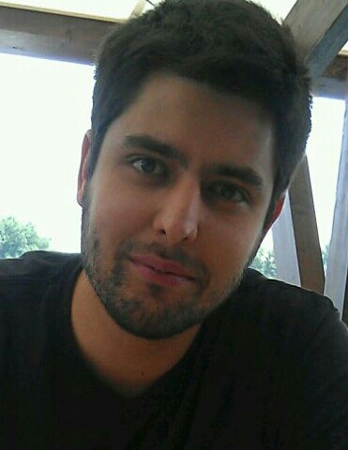

Date of birth: 17.11.1986.

Place of birth: Belgrade, Serbia

Citizenship: Republic of Serbia

Address: Srpskih udarnih brigada 7

11000 Belgrade, Serbia

Telephone: +381 11 3513845

Mobile: +381 60 3887443

E-mail: mihajlominic@outlook.com

**EDUCATION:**

2002. – 2006. High School **“Nikola Tesla“,** Department of Telecommunication.

2006. – 2008. Basic studies, Faculty of Electrical engineering ,University of Belgrade.

2008. - Basic studies, Faculty of transport and Traffic Engineering, University of Belgrade,

Department of Telecommunication (final year of study).

**ADDITIONAL QUALIFICATIONS:**

**Knowledge of languages**: Serbian (mother tongue)

English (fluent)

Italian (average)

**Computer skills**: MS Office, Windows, Linux, AutoCAD , MatLab, The

computer languages C and Pascal,LAN,TCP/IP.

**Other:** Possessing of driving licenses B and C categories.

**PERSONAL CHARACTERISTICS:**

Communicative

Responsible

Team player

Organized

Pervasive

Willing to take initiative

Creative

**HOBBIES, INTERESTS, ACTIVITIES:**

* Travelling and learning about other cultures and nations.
* Interested in new technologies (in the field of multimedia and IT ).
* Trained water polo for several years in club “Student“ and basketball in a local club.
* Sports fan (used to be a member of Faculty volleyball team).