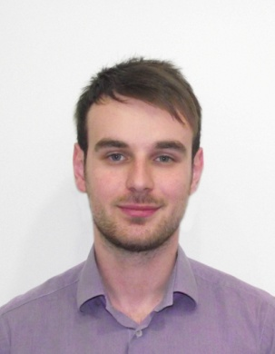

|  |
| --- |
| Milan Stjepanović |

**Adress:** Branka Ćopića 12, Belgrade

**Date of birth:** 14. February 1989.

**Mobile:** +381 64 5582 777

**E-mail:** [milanstjepanovic9@gmail.com](mailto:milanstjepanovic9@gmail.com)

|  |
| --- |
| EDUCATION |

* Bachelor’s degree in Faculty of organizational sciences, Belgrad 2008. – 2013.
* VI Belgrade gymnasium 2004. – 2008**.**

|  |
| --- |
| WORK EXPERIANCE |

* Marketing agency ‘’Moment’’ – Promotion Leader 2013. – 2014.
* Catering Company ‘’Sweet House’’ 2011. – 2012.

(product distribution)

* Practice during studies, related to faculty activities - Project management

|  |
| --- |
| PERSONAL SKILLS |

* Ambitious
* Comunicative
* Team Work
* Responsible
* Dedicated

|  |
| --- |
| PROFESSIONAL INTEREST |

* Marketing
* Sales
* Customer Care
* Project managemant
* Psychology

|  |
| --- |
| ADDITIONAL INFORMATION |

* Languages: Serbian – native

English – active

Spanish, German - passive

* Computer skills: (MS Office, Orange, Olap, MS Project, MS Access, Adobe)
* CRM expiriance - class related
* Case study: Special event planner
* Drivers licence: ‘’B’’ category.