 |  | 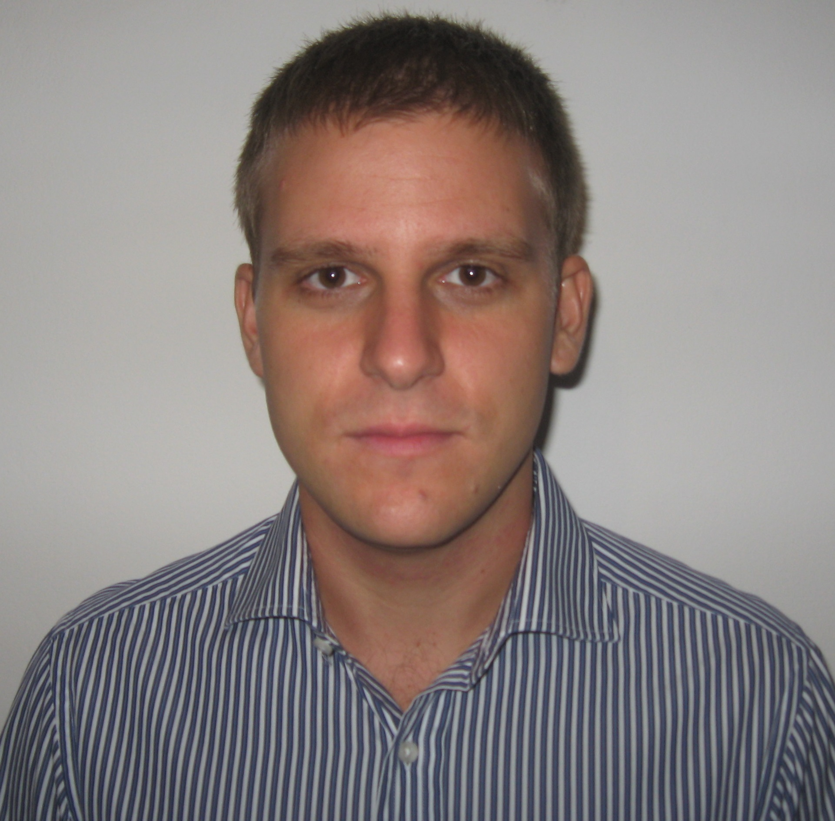
 |  |  |  |  |  |  | Jović Miloš
Bachelor of Economics
31.03.1985.
 |  | Address Milutina Milankovića 134/5, 11070 Beograd–Telephone 063/302-357 - 011/6130-855 - e_mail jovic.milos1985@gmail.com
 |  |  | Work experience |  |  |  |  |  |  |  |  | LEMIX d.o.o.  May 2012 - October 2012
 |  |  |  |  |  |  |  |  |  |  |  | Selling capacities of restaurant ”Kumbara”
- Visiting companies, embassies, banks, various insistution of the system
- Selling of the catering
- Contracting officies
- Corporate catering

EPOKSAN d.o.o.
April 2011 - November 2011
 |  |  |  |  |  |  |  |  |  |  |  | External co-worker for selling capacities
- Market research for selling floors, coatings, mastics
- Visiting of industrial facilities, warehouses, halls, schools, hospitals
- Presentations at fairs
 |  |  | Education |  |  |  |  |  |  |  |  | Dom za stare MeliorVita  April 2010 - September 2010  Administrative Officer  - Work with invoices  - Payments  - Completing and archiving of documents  - Communication with clients  Other jobs of different types through student collectives
X gymnasium “Mihajlo Pupin“, Belgrade
2000 - 2004

Faculty of Economics, University of Belgrade
2004 - 2013
- Module:International Economics and Foreign Trade
 |  |  | Technical skills and competences  Foreign languages  Social skills and competences  Driving licence |  |  |  |  |  |  |  |  | Microsoft Office Internet  - Word • Private and business  - Excel  English language  - Reading skills Excellent  - Writing skills Excellent  - Verbal skills Excellent  Responsible, precise, communicative, ready for teamwork, ready for further development, loyal, persistent  B

