**-*CURRICULUM VITAE-***

**PERSONAL DETAILS**

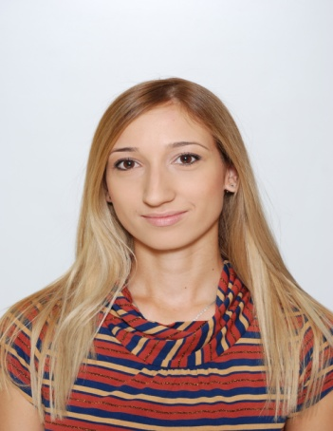

Name: Nataša

Surname: Mićić

Date of birth: January 2nd  1989

Place of birth: Požega, Republic of Serbia

Nationality: Serbian

Address: Ljubomira Ivkovića-Šuce 15-B

11090 Belgrade

Phone: +381(011)2382824

Mobile: +381(064)8806662

E – mail: nadja_micic@yahoo.com

**EDUCATION**

**-Master Studies, Faculty of Economics, University of Belgrade**

October/2013-present

Department of Strategic Financial Management

**-Faculty of Economics, University of Belgrade**

October/2008-September/2013

Bachelor of Economics

Department of Trade Management and Marketing

GPA 8,00/10,00

**-Secondary School “ Sveti Sava” Požega**

September/2004-June/2008

Department of Natural Sciences and Mathematics

**WORKING EXPERIENCE**

-Intern at “*Telekom Serbia*” a.d. ( Department of Accounting, TPC Sector), August 2012

( My assignments were working with data base, preparing documents, helping to employees)

**SPECIAL SKILLS**

Foreign languages: English (B1)[1]

Computers: MS Office (Word,Power Point,Excel), Internet

Driving license: *B category*

**BACKGROUND COURSES**

- Microsoft Excel 2007 Course (advanced level) Centar Wizard, June 2013 ;

- *„ Soft Skills Academy “,* april 2013;

* „ Business correspondence“ PwC,
* „ Presentation Skills“ Represent Communications,
* „ Motivation“ EESTEC,
* „ Project management“ CPM,
* „ Self and time management“ Ernst & Young,
* „ Logic structuration“ Deloitte,
* „Teamwork“ EESTEC,
* „ Leadership“ H.Art,
* „ Feedback“ EESTEC.

- *„Manage your career“*  Coca-Cola Hellenic, April 2013, Career Days ;

- Conference of Students of Economics, November 2012, Zlatibor;

- Conference *„Youth Enterpreneurs“*, May 2012, Office for Youth Belgrade;

- *Business Excel Course - Introduction to Business Decision Making and Financial Analysis*, April 2012, Faculty of Economics;

- Conference *FIDES*, April 2012, National Bank of Serbia;

- Conference *Forum of Youth Leaders*, February 2012, Bansko, Bulgaria;

- English Language Course Intermediate Level (B1) - The Center for Continuous Professional Development , Faculty of Economics .

**PERSONAL PROFILE**

-Reliable, responsible, well organized and very persistent;

-Good presentation and communication skills;

-Experienced in teamwork and capable of working under pressure.

**PERSONAL INTERESTS/HOBBIES**

Sports, books, movies, travellings, argentine tango, chess, music.

1. The Common European Framework of Reference for Languages