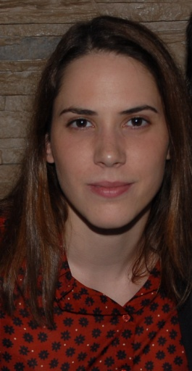
Full name : Sara Nikolić
Date of birth : 17.10.1987.
Address : Anastasa Jovanovića 3/10 , 11 000 Beograd
Mobile : +381 66 245 664
E-mail: saranikolic17@gmail.com

WORK EXPERIENCE

- Practicum at Atlantic Travel & Service travel agency, as a Sales Agent (March – May 2013)

EDUCATION

- Faculty of Economics, University of Belgrade (2006/07-2014)
Department of Marketing

- “Svetozar Marković“ Grammar School, Jagodina, Department of Mathematics
and Natural Sciences (2002-2006)

LANGUAGES

- English – Advanced

- German - Basic

SKILLS AND INTERESTS

- MS Office , Internet

- Development of Business Plans

- Driving Licence (B)

- Black belt in Karate

- Elementary Music School ''Vladimir Đorđević'' , Aleksinac - Guitar

