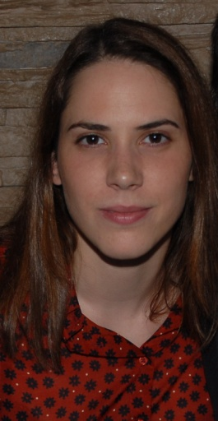

**Full name : Sara Nikolić**

**Date of birth : 17.10.1987.**

**Address : Anastasa Jovanovića 3/10 , 11 000 Beograd**

**Mobile : +381 66 245 664**

**E-mail:** [**saranikolic17@gmail.com**](mailto:saranikolic17@gmail.com)

|  |
| --- |
| WORK EXPERIENCE |

* Practicum at  **Atlantic Travel & Service** travel agency, as a **Sales Agent** (March – May 2013)

|  |
| --- |
| EDUCATION |

* **Faculty of Economics**, University of Belgrade (2006/07-2014)

Department of Marketing

* **“Svetozar Marković“ Grammar School**, Jagodina, Department of Mathematics

and Natural Sciences (2002-2006)

|  |
| --- |
| LANGUAGES |

* **English** – Advanced
* **German** - Basic

|  |
| --- |
| SKILLS AND INTERESTS |

* MS Office , Internet
* Development of Business Plans
* Driving Licence (B)
* Black belt in Karate
* Elementary Music School  ''Vladimir Đorđević'' , Aleksinac - Guitar