**Curriculum Vitae**

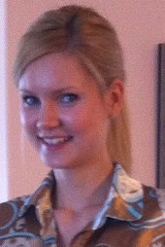

**Tamara Šošević**

**Date of birth**: 17.05.1988.

## Adress: Mihaila Todorovića 14e/18, Belgrade

## Phone: +38169 2537978

## +38111 3476941

**E-mail**: tamara.sosevic@yahoo.com

|  |  |  |  |
| --- | --- | --- | --- |
| Education: | | | * **University of Belgrade, Faculty of Economics.** * Module: International Economy and Foreign Trade * Submodule: International Finance * (2006-2014) * **II Ekonomska škola,** Belgrade (2002-2006) |
| Work experience: | | | * **Synovate** market research agency and public opinion polling   (2007-2008)-interviewer, Belgrade   * **Frikom** (march-september 2013)- promo leader, Belgrade * **“Work and travel”** program (may-october 2011 I june-october 2013)-   Restaurant manager “Cedric”, NYC, hostess in bar “Wicked Willyꞌs”,  NYC   * **“Ulica otvorenog srca”-**organizer, Belgrade * **2008 Uneversiade**-organizer, Belgrade * **MEDIKA PROJEKT** (july-october 2014)-internship |
| Seminares and practices : | * Seminar “Exit from the economic crisis”, Zlatibor, november 2012. | | |
| Computer skills: | | | * MS Office package (Excel, Word, Power Point) * Internet |
| Languages: | | | * English (intermediate level) * Spanish (basic level) |
| Personal features: | | | * Patient and persistent, flexible, organized, communicative,   focused on goals, ready for advanced training and learning new skills |
| Other: | | | * Driving licence B category |