Curriculum vitae

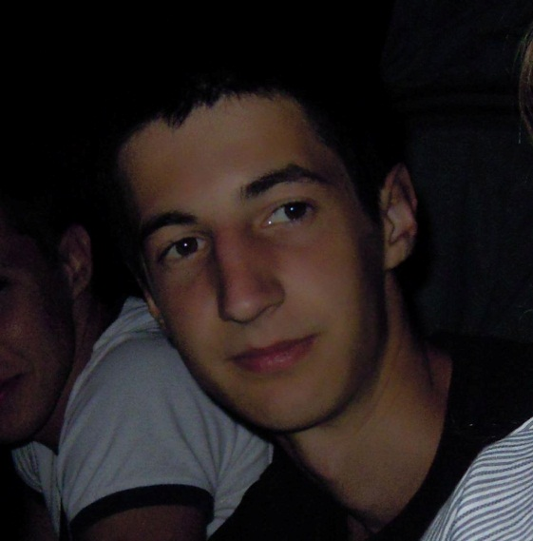**Contact information:**

First name: Aleksa

Last name: Milosevic

Address: Makenzijeva 85, 11000

Belgrade, Republic of Serbia

Telephone: +381 69 2453 949

Email: [a.milosevic93@gmail.com](mailto:a.milosevic93@gmail.com)

**Personal information:**

Date of birth: 6th of August, 1993.

Place of birth: Belgrade, Republic of Serbia

Citizenship: Republic of Serbia

Sex: Male

Marital status: Single

**Education:**

* Graduated from Mathematical High School in Belgrade, class of 2012
* Started studying Software engineering at Faculty of electrical engineering, University of Belgrade in 2012.
* After an outstanding first year of studies (9.88 GPA), I was offered by faculty dean to try studying at accelerated program (completing 90 ECTS per school year during 2013-2014 and 2014-2015 school years, with a goal of graduating one year earlier than regular students). Since Software engineering studies normally take 4 years (240 ECTS) in this faculty, my projected year of graduation is 2015.

**Working and competition experience:**

* Intern at Lukoil Srbija a.d. for 2 months during summer of 2013, worked on adjusting SAP accounting software for specific needs of this company
* Regularly working as student-assistant at Faculty of electrical engineering, University of Belgrade since 2013, with work assignments being:
  + Checking and grading younger students’ homework
  + Mentoring younger students during their work on school projects
  + Being on duty during exams
  + Showing demonstrations during laboratory exercises for younger students
  + Grading younger students’ work during laboratory exercises
* In spare time, i work on designing and building websites with two colleagues from faculty
* In 2013, entered “Build the future”, EESTEC organized international competition in creating social networks, won 2nd place

**Professional skills:**

* Software developing languages: C, C++, C#, Java, SQL
* Web development languages: HTML, CSS, JavaScript, PHP
* Operating systems: Microsoft Windows, Linux
* Environments: Eclipse, Visual Studio, SQL Server Management Studio
* Other technologies: .NET Framework, including ASP.NET (MVC), ADO.NET

**Other skills:**

* Languages: Serbian, English (fluent, attended English classes for 13 years, also travelled a lot), French
* Hard working, responsible, well organized, very devoted to my work