PERSONAL INFORMATION | Jovana Petrović
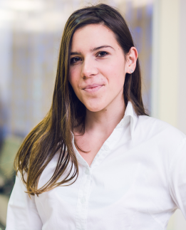 | 43a,Kumodraska, 11000 Belgrade (Serbia)
 | +381605600656
 | jovanapetrovic81@gmail.com
 | Sex Female | Date of birth 27/04/1994 | Nationality Serbian

WORK EXPERIENCE

16/09/2016–15/10/2016 | Practitioner
 | Banca Intesa d.o.o., Belgrade (Serbia)
 | Business or sector Financial sector, Human Resources and Project Management

09/2015–09/2017 | Member of the student organization ESTIEM

07/12/2015–23/12/2015 | Team member on project case study section
 | www.estiem.org.rs
-selection and communication with sponsors
-searching for people who will hold the lectures on the project
-cooperation and contact with the media (​radio,television,press,internet)

09/07/2016–15/10/2016 | Member of PR team on the project Vision FInal Conference
-creating tizers for foreign participants
-contact with the media (radio,television,​press,internet)
-making a promo video

EDUCATION AND TRAINING

01/09/2009–30/05/2013 | High School Diploma
Četrnaesta beogradska gimnazija, Belgrade
www.cetrnaestgim.edu.rs
Grammar School program:
​Mathematics, Physics, History, Geography, Chemistry, Philosophy, English..

01/10/2013–20/09/2017 | Graduated of Management and Organizational Studies
Faculty of Organizational Sciences,University of Belgrade
154 Jove Ilića,
www.fon.bg.ac.rs
Subjects:
Statistics,Accounting,Financial management,Economics,Management,Mathematics,Information systems,Probability,Econometrics,Financial Markets,Investment banking,Managerial accounting,Marketing,PR​

PERSONAL SKILLS

Mother tongue(s) | Serbian
Other language(s) | UNDERSTANDING |  | SPEAKING |  | WRITING
 | Listening | Reading | Spoken interaction | Spoken production
English | B2 | C1 | B2 | B2 | B2
 | Certificate Institute of foreign languages
Italian | A1 | A2 | A1 | A1 | A1
Levels: A1 and A2: Basic user - B1 and B2: Independent user - C1 and C2: Proficient user
Common European Framework of Reference for Languages

Communication skills | -communicative  -opened for conversation  -direct  -accept criticism​  -open-minded

Job-related skills | -disciplined  -responsible​

Digital competence | -MS Office  -PhotoShop
Driving licence B

