PERSONAL INFORMATION | Bojana Savić
0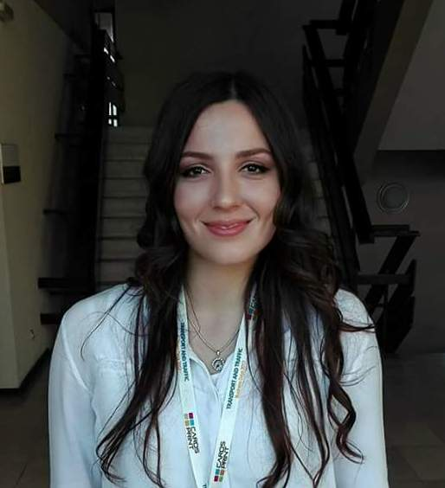 | Kumodraška 99., Voždovac, 11000 Belgrade (Serbia)
 | +38164 3809990
 | bsavic.sf@gmail.com
 | www.linkedin.com/in/bojana-savić-6b5233144/
 | Sex Female | Date of birth 10/04/1995 |

WORK EXPERIENCE

May 2018- October 2018 | Sales Associate  Trapper Jack’s Trading Post  340 W, 4th Avenue, Anchorage, Alaska  - Assisting customers  - Restocking merchandise  - Operating cash register  - Cleaning store

May 2018- October 2018 | Bartender  Flattop Pizza and Pool  600 W, 6th Avenue, Anchorage, Alaska  - Setting the bar  - Preparing alcoholic or non-alcoholic beverages  - Interacting with customers, taking orders and serving  - Assessing bar customers’ needs and preferences and making recommendations
May 2018- October 2018  September 2017- March 2018 | Server/ Expo/ Food Runner  Humpy’s Great Alaskan Alehouse  610 W, 6th Avenue, Anchorage, Alaska  - Greeting customers  - Taking orders  - Running food  - Processing payment  - Cleaning and setting tables and dining area
Data Collection and Labeling Associate

Microsoft Development Center Serbia
Španskih boraca 3, Belgrade, Serbia
- Collection and labeling of data samples
- Data analysis
- Evaluation of data collection and labeling tool features
- Providing feedback in written and verbal form
- Regulary writing reports and communicating with the rest of the team

EDUCATION AND TRAINING
October 2017- Present  October 2013 – October 2017 | Master studies, Faculty of Transport and Traffic Engineering- Logistic Department  Faculty of Transport and Traffic Engineering, University of Belgrade, Serbia  Graduate Traffic Engineer in Logistic area, Faculty of Transport and Traffic Engineering- Logistic Department
 | Faculty of Transport and Traffic Engineering, University of Belgrade, Serbia
 | .
PERSONAL SKILLS

Native language(s) | Serbian
Other language(s) | UNDERSTANDING |  | SPEAKING |  | WRITING
 | Listening | Reading | Spoken interaction | Spoken production
English | B2 | B2 | B2 | B2 | B2
Italian | A2 | A1 | A1 | A1 | A1
Spanish | B1 | B1 | A2 | A2 | A2
German | A1 | A1 | A1 | A1 | A1
Levels: A1/2: Basic user - B1/2: Independent user - C1/2 Proficient user
Common European Framework of Reference for Languages

Communication skills | - Listening skills  - Communicating powerfully in writing  - Communicating impressively face- to- face  - Giving great presentations

Organisational / managerial skills | - Leadership  - Handling details  - Identifying problems  - Negotiation  - Presentation  - Problem solving

Tehnicall skills | Work in Microsoft Office Package programms, Autocad, Inkscape, Arena, Flexsim

Driving licence | B category

ADDITIONAL INFORMATION

Science work

Conferences

“Intermodal Transport in Danube Region”
Logic Conference 2017, Belgrade, Serbia

Transport and Traffic business Days 2016, Belgrade, Serbia
Transport and Traffic business Days 2017, Belgrade, Serbia
Transport and Traffic business Days 2018, Belgrade, Serbia

PERSONAL INTERESTS

Travelling
Meeting different cultures and seeing both ancient and modern monuments is beautiful experience for me. Whenever i have free time i use it for travelling.
Salsa
I have been dancing salsa for a while and since then, salsa inspired me to learn Spanish language, learn about Latin culture and people.

