**Teodora Popović**

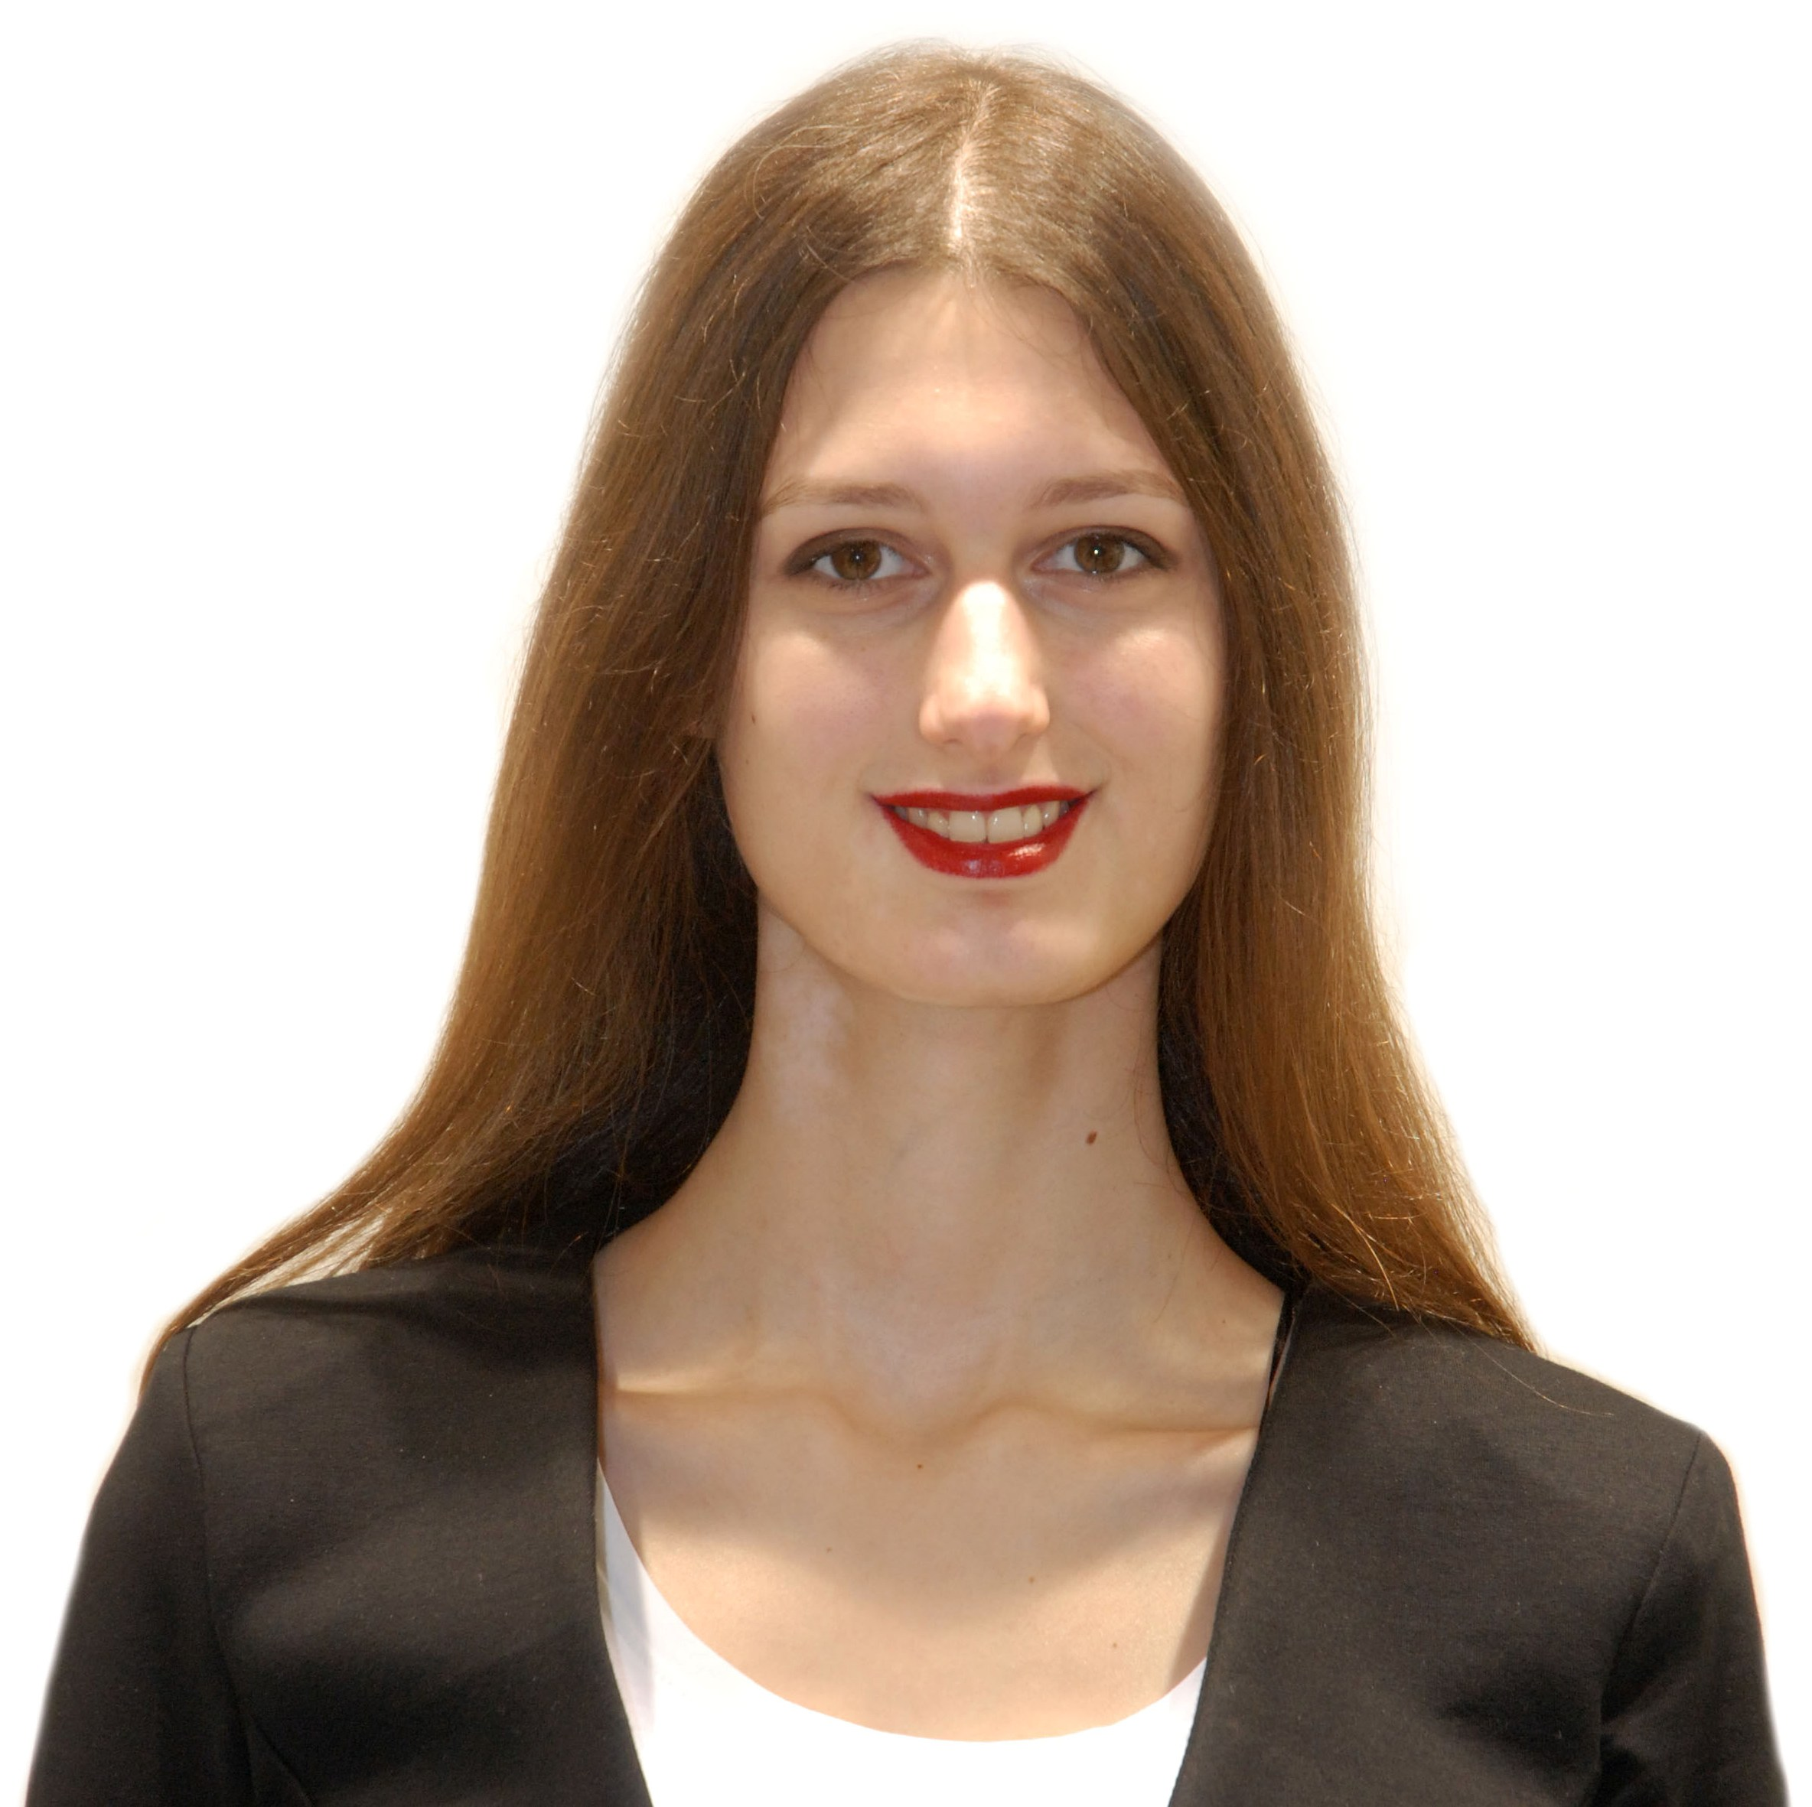

Jablanička 68, Cerak, Belgrade

email: [tea.popovic55@gmail.com](mailto:tea.popovic55@gmail.com) Tel: 065/ 8220- 205

**Personal Statement**

I am a self-motivated person with a great interest to develop new skills and gain many new professional experiences, especially in the field of marketing and management, but also in many more. I am dedicated and well organised.

**Working experience**

November 2016 – December 2017, Brand Ambassador at Ahold Delhaize

* Presenting team proposals for improving business performance with focus on Marketing and Category Management (4 projects)
* Representing and increasing the brand value of the company
* Promoting the activities of the company on social pages
* Creating new ways to deliver the brand message to customers
* Representing the company at conferences and student events (Career Days, Job Fair)

August 2016 , Credit Risk Department, Vojvođanska Banka

October 2015, Vojvođanska Banka Case study

(problem solving in a team, using organisational, communicational and decision - making skills)

**Education and Qualifications**

2013 -2018 Bachelor degree in Economics, Faculty of Economics, University of Belgrade

*Module: marketing and trade management*

2009 - 2013, Thirtheenth Belgrade high school, Belgrade

*Module: socio-lingual sciences*

**Trainings and Seminars**

* Coca Cola HBC Training programme (Business communication, Project management,

Project planning, Time management and Business administration)

* “MS Office- Excel” course, Faculty of Economics, University of Belgrade
* Marketing course “Visual economy”, Faculty of Economics
* “Team work” training, Delhaize Serbia
* “Change management” training, Delhaize Serbia
* “Leadership” training, Delhaize Serbia
* “Assertive communication” training, Delhaize Serbia
* Conference of Economists „Konekt“ , Faculty of Economics, University of Belgrade
* Career Days: Career Workshops in Belgrade
* Build Yourself Conference, Faculty of Economics
* Career and Entrepreneurship Opportunities (CEO) Conference, Belgrade
* Economic Student Summit „Think Big“
* Full time general English course at Advanced level, New Colledge Nottingham, United Kingdom

**Skills**

* MS Office, MS Excel, MS Word
* IBM SPSS Statistics v.23

**Abilities**

* Able to work on tasks individually or as part of a team.
* Problem solving.
* Able to focus on accuracy and attention to detail whilst under pressure and against deadlines.
* Excellent organizational skills.
* Able to communicate concepts and strategies clearly to colleagues.
* Ability to understand problems and then develop imaginative and inventive solutions.
* Open minded and non-judgemental.
* Good listener.

**Languages Speaking Writing Reading Comprehension**

English excellent excellent excellent excellent

**Hobbies**

I like being creative and take time to draw and design. Also, I am interested in reading books about social psychology and human behavior.